Scaling

What is Scaling?

Scaling out a Deployment will ensure new Pods are created and scheduled to Nodes with available resources. Scaling will increase the number of Pods to the new desired state.

Running multiple instances of an application will require a way to distribute the traffic to all of them.
Scaling is accomplished by changing the number of replicas in a Deployment. Once you have multiple instances of an Application running, you would be able to do Rolling updates without downtime.

Hands On – Scale a deployment through both declarative and imperative methods

I. Declarative Scaling:

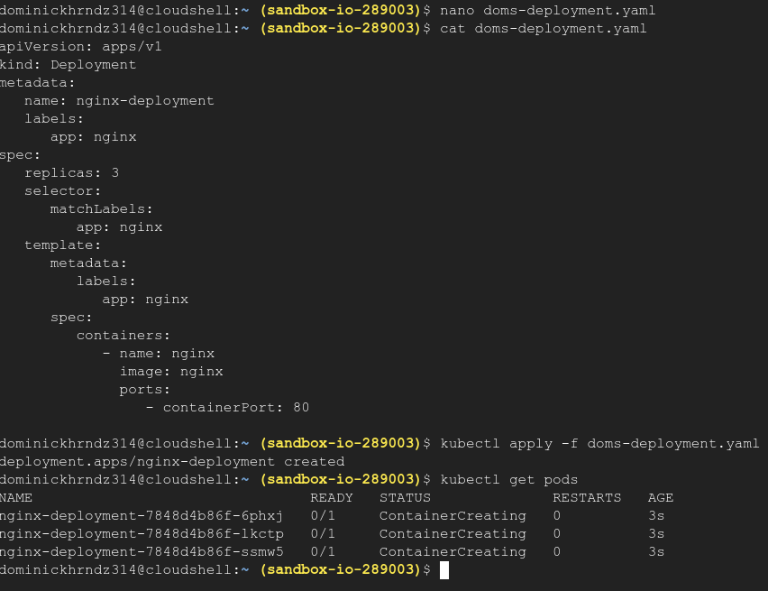
Let’s first start by creating a deployment file, thus applying a declarative change. Create 3 pods running nginx, apply, and verify.

Now let’s scale the number of replicas to 5 using the declarative method. Go back into your file and change the replicas field from the 3 to 5. Save your changes, apply the config, and verify.
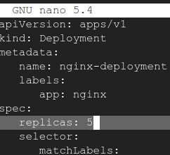

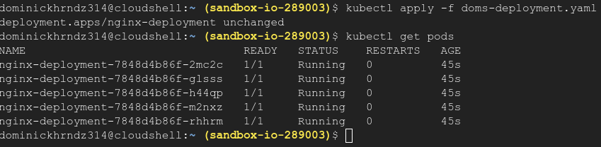
II. Imperative Scaling:
Now lets use imperative commands to scale our deployment back down to 3 pods instead of 5. we can use the kubectl scale –replicas=3 deployment nginx command to accomplish this.

